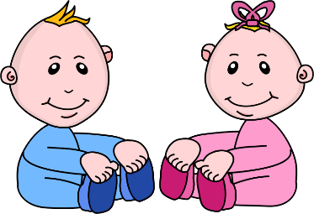
Infant room Lesson plan
Date: March 12th-16th
Teachers: Ms. Amanda, Ms. Carmen, Ms. Kallie, Mrs. Jessica and Ms. Nicole
Bible verse: “God gave us eyes to see and ears to hear” (Prov 20:12)
I can see and hear
Books  Reading a peek-a-boo picture: Use 6 pictures of familiar items to younger babies and paste them to a piece of paper. Cut holes in another paper and cut flaps over the pictures. Play peek-a-boo pictures with babies. Say “thank you god for our friends” | Motor Development  Reaching for a bottle with bubbles: Fill a water bottle with water and a small amount of dish soap and seal it shut. Encourage the babies to hold the bottles and shake them. Using descriptive language, talk about the bubbles they are making.
Art  Painting with sponges: Gather a couple sponges, attach a clothes pin to each sponge using it as a handle. Guide the babies to press the sponge onto the paper. As the child is painting thank god for eyes to see the beautiful colors. | Music  Shaking jingle bells: make musical shakers by putting bells in bottles covered in contact paper. Give the shakers to the children and play upbeat music. Sing and clap while they are playing with the shakers. Say “we thank god for ears to hear the music”
Nature  Taking a walk outdoors: put the children into the buggy, and take them outside. Look for birds, grass, and trees. Using descriptive words tell them about what they see and thank god for their eyes to see. | Toys  Playing with rattles: place rattles in your pocket sand as you have the opportunity shake the rattles at the children. Try to get the babies to follow the rattles with their eyes, for visual stimulation.

