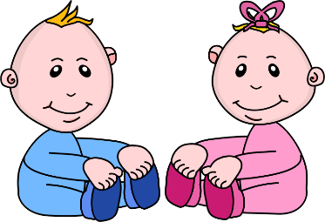
Infant Room Lesson Plan
Date: March 5th-9th
Teachers: Ms. Amanda, Ms. Carmen, Ms. Kallie, Mrs. Jessica and Ms. Whitney
Bible verse: “God made me” (ps. 139:14)
I am growing
Books  Books in a bag: Attach a small bag to the side of the rocking chair. Locate several books about babies and place them in the bag. Read to the babies as you rock them throughout the day. | Motor Development  How big game: As you play with children on the floor, ask them “how big are you?” As you ask them, raise your arms over your head. Encourage them to lift their hands over their head in response. Emphasize that all children are uniquely growing to gods plan.
Art  Zip-Lock-Bag painting: use soft colors of construction paper and dark colored crayons to trace the babies hands. As you trace the babies hand, sing the song “I love to clap my hands” allow child to clap their hands. Say “thank you god for my hands” | Music  Diaper Music: place a child-safe mirror at the changing table so the babies can see their face while being changed. Sing “look at baby” to the tune of “are you sleeping”
Nature  Baby sounds: use a sound recorder to record baby sounds. Sit on the floor with a small group of infants and play infant sounds to them. Describe the sounds that they hear. | Toys  Bowl of beads: Place a bowl of snap-lock beads in a bin on the floor. Show them how they snap together and pull apart. Describe the texture, size and color of the beads to the children.

