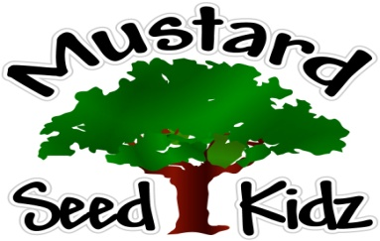
March 12th-16th

Breakfast | Monday | Tuesday |  | Wednesday | Thursday | Friday
 | Corn Flakes  Peaches  Milk | Blueberry Muffin Cake  Applesauce  Milk |  | Chex  Fruit Cocktail Milk | Cereal Fruit Bar  Banana Slices  Milk | Honey Nut Cheerios  Apple Sauce Milk
Lunch | Chicken Nuggets  Mashed Potatoes  Fruit Cocktail  Milk |  | Meat Ravioli  Corn  Salad  Milk | Beanie Weenies  Roll  Apple Sauce  Green beans  Milk | Teriyaki Chicken  Rice  Broccoli  Pears  Milk | Turkey or Ham Cheese Wrap  Carrots with Ranch  Peaches  Milk
Snack | Pretzels  Cheese Dip | Goldfish  Celery |  | Tortilla chips  Salsa | Cheese & Crackers | Fruit bread  100% Apple Juice

