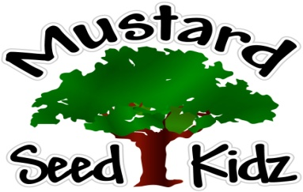
March 19th – 23rd

Breakfast | Monday | Tuesday |  | Wednesday | Thursday | Friday
 | Kix  Applesauce  Milk | Orange Cranberry Bread  Orange Sections  Milk |  | Raisin Bran  Applesauce  Milk | Cereal bar  Peaches  Milk | Cheerios  Pineapple  Milk
Lunch | Corn Dog  Tater Tots  Green Beans  Fruit Cocktail  Milk |  | Italian Chicken  Yellow Rice  Broccoli  Peaches  Milk | Cheese Pizza  Salad w/Ranch  Pineapple  Milk | Ham  Macaroni Salad  Pickles  Pears  Milk | Turkey Soft Tacos  Salsa  Sour Cream  Corn  Fruit Cocktail  Milk
Snack | Gold Fish  Carrots or Celery | Chex Mix  Raisins |  | Pretzels  Cheese Sauce | String Cheese  Crackers | Apple Juice  Multi Grain Crackers

