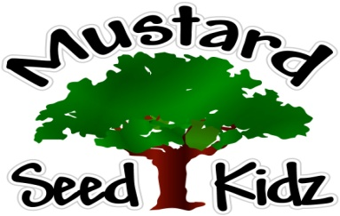
March 5th-9th
Breakfast | Monday | Tuesday |  | Wednesday | Thursday | Friday
 | Rice Crispy  Fruit Cocktail  Milk | Fruit Cereal Bar  Applesauce  Milk |  | Kix Cereal  Peaches  Milk | Banana Muffin  Banana Slices  Milk | Cheerios  Peaches  Milk
Lunch | Chicken Nuggets  Mashed Potatoes  Pears  Milk |  | Hot Dog on a Bun  French Fries  Pineapple  Milk | Chicken & Rice Casserole  Broccoli  Fruit Cocktail  Milk | BBQ Chicken Sandwich  Salad w/Ranch  Peaches  Milk | Ham and Cheese Wrap  Carrots  Tropical Fruit  Milk
Snack | Goldfish w/  Celery | Tortilla Chips  Salsa |  | Cheese &  Crackers | Chex Mix  Raisins | Chocolate Chip Bread  Milk

