Sunscreen everyday would be a good idea
 | ~ July 2018~
Sun | Mon | Tue | Wed | Thu | Fri | Sat
 | 2 Aquatic Center  Palm Bay  Leave @12:30pm | 3 Blowing Rock and Light house Tours  This Photo by Unknown Author is licensed under CC BY-SA  Leave school by 9:30 am | 4  MSK Closed Independence Day | 5 Reptile  World  leave@9:45am | 6 On the Edge  Rock Climbing  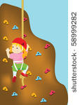  Leave@ 9:30am
 | 9 Aquatic Center  Palm Bay  Leave @12:30pm | 10 Children’s Museum  Leave by 8:30 | 11Movies  Field of Dreams Park  Leave @ 8:30am | 12  You Jump!  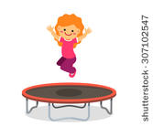  Leave school by 9:45am | 13 Painting with a Twisty ConeKona Ice truck visit!!
 | 16 Aquatic Center  Palm Bay  Leave @12:30pm | 17 Pump it Up  This Photo by Unknown Author is licensed under CC BY  Leave by 12:15pm | 18 Movies  Field of Dreams Park  Leave @ 8:30am | 19 Pump it Up  Leave @ 12:30pm | 20 World of Chocolate  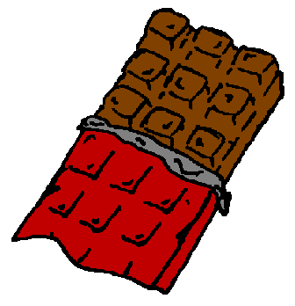  Leave by
 | 23 Aquatic Center  Palm Bay  Leave @12:30pm | 24 Bowling  Leave by 9:30am | 25 Movies  Field of Dreams Park  Leave @ 8:30am | 26 Fred Lee Park  Sports Day  Leave school by 10:00am | 27Brevard Zoo  This Photo by Unknown Author is licensed under CC BY-NC-ND  Leave school at
 | 30 Malabar Park 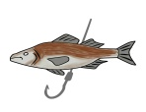Leave school by 10:00am

Notes:
***BST: Children will need a bathing suit, a towel and sunscreen ALREADY ON prior to arriving at the center***

