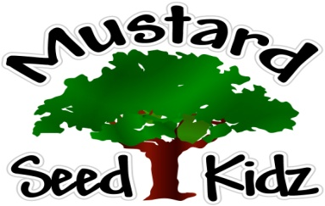
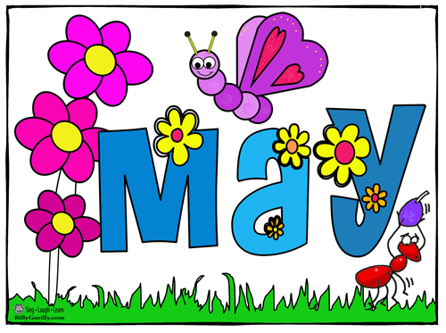
May 14th- 18th

Breakfast | Monday | Tuesday |  | Wednesday | Thursday | Friday
 | Cheerios  Fruit Cocktail  Milk | Cereal Bar  Pears  Milk |  | Corn Flakes  Applesauce  Milk | Apple Cinnamon Muffin  Mandarin Oranges  Milk | Life  Bananas  Milk
Lunch | Chicken Nuggets  Mashed Potatoes  Peaches  Milk |  | Corn Dog  Tater Tots  Mixed Vegetables  Fruit Cocktail  Milk | Mexican chicken Casserole  Corn  Pineapple  Milk | Ravioli with meat sauce  Broccoli  Applesauce  Milk | Pepperoni Pizza  Salad  Fruit Cocktail  Milk
Snack | Tortilla Chips  Salsa | Cheese & Goldfish Crackers |  | Chex Mix  Raisins | Celery and Carrots with Ranch | Apple Bread  Apple Juice

