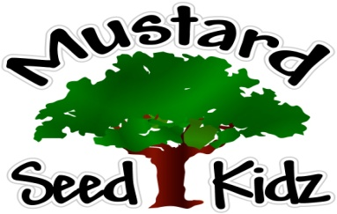
May 21st – 25th

Breakfast | Monday | Tuesday |  | Wednesday | Thursday | Friday
 | Corn Flakes  Fruit Cocktail  Milk | Wild Berry Muffin  Applesauce  Milk |  | Life  Pineapple  Milk | Cereal Fruit Bar  Banana Slices  Milk | Cheerios  Pears  Milk
Lunch | Chicken Nuggets  Sweet Potato Fries  Green Beans  Milk |  | Beef Shepard’s Pie  Mixed Veggies  Mashed Potatoes  Tropical Fruit  Milk | Meatballs  Mac & Cheese  Peas& Carrots  Peaches  Milk | Chicken Rice  Broccoli Casserole  Fruit Cocktail  Milk | Ham & Cheese Wraps  Pickles  Pineapple  Milk
Snack | Goldfish  Cheese Slices | Chex Mix  Raisins |  | Carrots & Celery  w/ Ranch | Pretzels  Cheese | Oatmeal raisin  Bread  Milk

