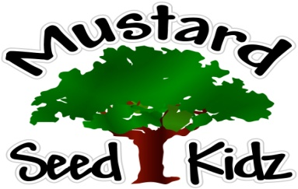
May 28th – June 1st
Breakfast | Monday | Tuesday |  | Wednesday | Thursday | Friday
 | MSK  Closed | Alpha Bits  Cereal  Pears  Milk |  | Chex Cereal  Banana  Milk | Cereal Bar  Apple sauce  Milk | Reduced Sugar Cinnamon Toast Crunch  Fruit Cocktail  Milk
Lunch | Memorial Day |  | Hot Dog on a bun  Corn  Fruit Cocktail  Milk | Chicken Alfredo  With broccoli  Peaches  Milk | Baked Ziti  w/whole wheat pasta  Caesar  Salad  Mandarin Oranges Milk | Turkey and Cheese on a bun  Pickles  Celery  Milk
Snack | Have a safe Holiday | Chex Mix  Raisins |  | Celery  Goldfish | Pretzels  Cheese Dip | Sun Chips  100 % Apple juice

