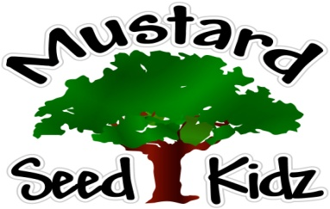
August 13th-17th
Breakfast | Monday | Tuesday |  | Wednesday | Thursday | Friday
 | Cheerios  Fruit Cocktail  Milk | Rice Crispy  Peaches  milk |  | Apple Cinnamon  Muffin  Banana slices  Milk | Cereal Bar  Apple sauce  Milk | Corn Flakes  Pineapple  Milk
Lunch | Beeef ravioli  Corn  Pears  Milk |  | Hot Dog on a bun  Mixed Vegetables  Fruit Cocktail  Milk | Chicken $ Rice  With broccoli  Peaches  Milk | Baked Ziti  w/whole wheat pasta  Caesar  Salad  Mandarin Oranges Milk | Turkey and Cheese on a bun  Pickles  Apple Sauce  Milk
Snack | Tortilla Chips  Salsa | Chex Mix  Cranberries |  | Wheat Thins  Cheese | Pretzels  Cheese Dip | Oatmeal Bar  Apple Juice

