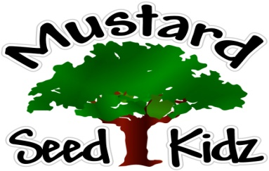
August 20th-24th
Breakfast | Monday | Tuesday |  | Wednesday | Thursday | Friday
 | Cheerios  Fruit Cocktail  Milk | Rice Crispy  Peaches  milk |  | Blue berry  Muffin  Banana slices  Milk | Cereal Bar  Apple sauce  Milk | Corn Flakes  Pineapple  Milk
Lunch | Chicken Nuggets  Mashed Potatoes  Pears  Milk |  | Macaroni and Ham  Green Beans  Fruit Cocktail  Milk | Chicken Fettuccini Alfredo  With broccoli  Peaches  Milk | Grilled Cheese  French Fries/or Tater Tots  Pickles  Mandarin Oranges  Milk | Turkey Tacos  Yellow Rice  Diced Tomatoes  Pineapple  Milk
Snack | Tortilla Chips  Salsa | Chex Mix  Cranberries or Raisins |  | Wheat Thins  string Cheese | Pretzels  Cheese Dip | Chocolate Chip Muffin  Apple Juice

