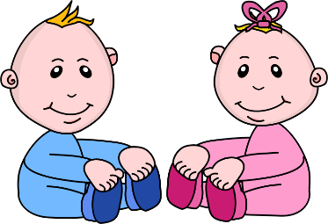
Infant Room Lesson Plan
Date: October 8th-12th
Teachers: Ms. Amanda, Ms. Carmen, Ms. Courtney, Mrs. Donna, Ms. Kaylee
Bible Verse: “Jesus loves you” (John 15:12)
I am learning about me
Books  Book basket: Spread a small quilt out onto the floor. Locate several books about babies and place into a small basket on the floor. Read to them as the children show interest. | Motor Development  Hear a rattle: Shake a rattle on the right side of a child’s head. After they turn their head, shake the rattle on the other side, and wait for the child to turn their head and say, “Thank you God, for letting us hear sounds.”
Art  My body picture: Print out a picture of an outline of a body. Help the children color the body parts as you tell them what each one is. Thank God for each one. | Music  Songs about me: Get a small group and sing head, shoulders, knees, and toes. Show them where each body part is as your singing the song.
Nature:  Bubbles: During outside time, take bubbles onto the mat. Sing the “bubble song” as your talk about the colors in the bubbles. Tell the children about wind outside. | Toys  Playing with toys: Sit with a group of children on the mobile side and gather some little toys that they like to play with and just play with them and explain what each toy is and show them how to use it.

