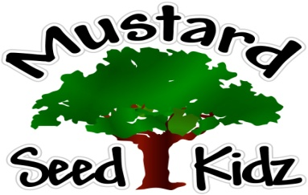
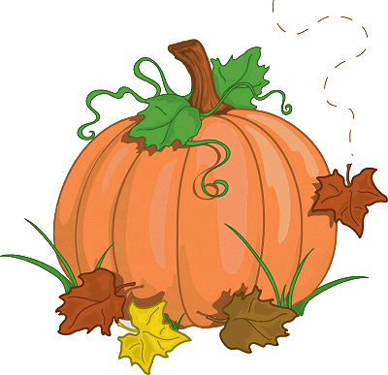
October 1st-5th
Breakfast | Monday | Tuesday |  | Wednesday | Thursday | Friday
 | Raisin Bran or Corn Flakes  Peaches  Milk | Wild Berry Muffin  Fruit Cocktail  Milk |  | Cheerios  Applesauce  Milk | Cereal Fruit Bar  Banana Slices  Milk | Life  Pineapple  Milk
Lunch | Chicken Nuggets  Mashed Potatoes  Fruit Cocktail  Milk |  | Turkey Soft Tacos  Salsa/ Sour Cream Corn  Pineapple  Milk | Beanie Weenies  Peas& Carrots  Peaches  Cornbread  Milk | BBQ Chicken Sandwich  Green beans  Pineapple  Milk | Beef Ravioli  Mixed Vegetables  Fruit Cocktail  Milk
Snack | Pretzels  String Cheese | Goldfish  Celery or carrots |  | Chex Mix  Raisins | Cheese & Crackers | Blueberry bread  Milk

