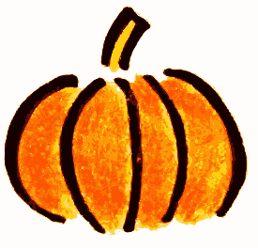VPK October Newsletter

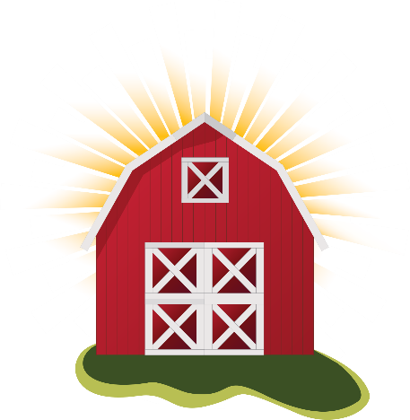“Treat Others Sweet Like You Would Jesus”

Mark Your Calendar!

* VPK Bake Sale: Oct. 8th-19th.
* LaPorte Farms Field Trip:

Linda/ Britney Class- Oct. 9th

Heather/Regina/Mary- Oct 11th

* Dress Like A Farmer Day!- Oct 10th
* Firetruck Visit- Oct 17th at 10:00
* Parents Night Out- Oct 19th
* Fall Festival- 10/31

Keep an eye out for flyers from your child’s teacher to tell you more information about each event!

Color of the Month:

Orange

Shape of the Month: Triangle

Monthly Peek:

October 1-5: Life on the Farm (F/6)

October 8-12: Machines and More/ Farm Equipment (G/7)

October 15-19: God’s Fall Gifts (H/8)

October 22-26: God’s Fall Gifts (I/9)

October 24-28: Insects and Spiders (J/10)