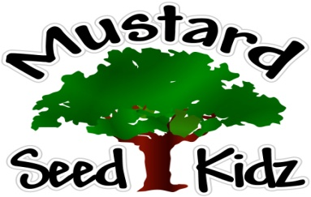
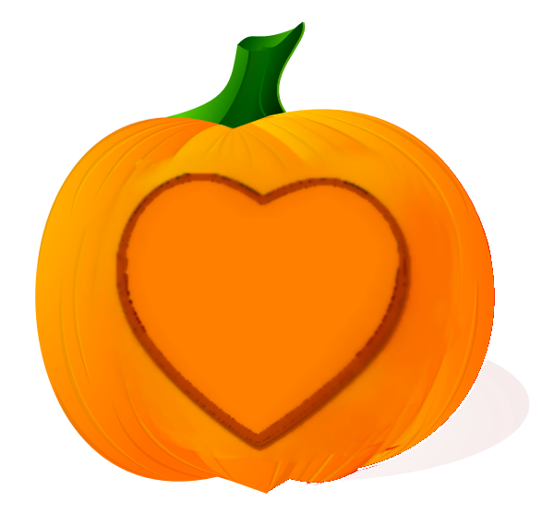
October 8th-12th
Breakfast | Monday | Tuesday |  | Wednesday | Thursday | Friday
 | Cheerios  Cereal  Pears  Milk | Apple cinnamon Muffin  Peaches  Milk |  | Chex Cereal  Banana  Milk | Cereal Bar  Apple sauce  Milk | Rice Crispy  Fruit Cocktail  Milk
Lunch | Chicken Nuggets  Sweet Potato Fries  Green Beans  Pineapple  Milk |  | Hot Dog on a bun  Corn  Fruit Cocktail  Milk | Chicken Alfredo  With broccoli  Peaches  Milk | Baked Ziti  w/whole wheat pasta  Caesar  Salad  Mandarin Oranges Milk | Turkey and Cheese on a bun  Pickles  Celery  Milk
Snack | Sting Cheese  Wheat Thins | Chex Mix  Raisins |  | Celery  Goldfish | Pretzels  Cheese Dip | Graham Crackers  100 % Apple juice

