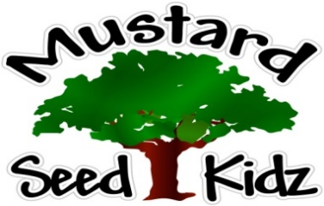
`

October 15th -19th
Breakfast | Monday | Tuesday |  | Wednesday | Thursday | Friday
 | Cheerios  Applesauce  Milk | Rice Crispy  Peaches  milk |  | Blue berry  Muffin  Fruit Cocktail  Milk | Cereal Bar  Banana slices  Milk | Corn Flakes  Pineapple  Milk
Lunch | Chicken Nuggets  Mashed Potatoes  Pears  Milk |  | Ham &  Macaroni (WG)  Green Beans  Fruit Cocktail  Milk | Spaghetti (WG)  with  meat sauce broccoli  Peaches  Milk | Grilled Cheese  French Fries/or Tater Tots  Pickles  Mandarin Oranges  Milk | Turkey Tacos  Yellow Rice  Diced Tomatoes  Pineapple  Milk
Snack | Tortilla Chips  Salsa | Chex Mix  Cranberries or Raisins |  | Wheat Thins  Pepperoni Slices | Pretzels  String Cheese | Oatmeal Bar Muffin  Apple Juice

