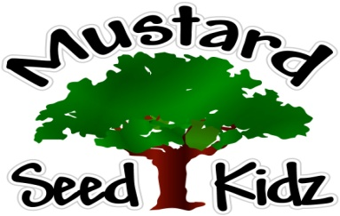
October 22nd-26th
Breakfast | Monday | Tuesday |  | Wednesday | Thursday | Friday
 | Cheerios  Applesauce  Milk | Orange Cranberry Bread  Orange Sections  Milk |  | Rice Crispies  Applesauce  Milk | Cereal bar  Peaches  Milk | Kix  Pineapple  Milk
Lunch | Corn Dog  Sweet Potato fries  Green Beans  Fruit Cocktail  Milk |  | Italian Chicken  Yellow Rice  Broccoli  Peaches  Milk | Sloppy Joe on a bun  Mixed veggies  Pears  Milk | Ham Cheese and veggie frittata  Hash browns  Salsa  Milk | Turkey Soft Tacos  Salsa  Sour Cream  Corn  Pineapple  Milk
Snack | Gold Fish  Carrots or Celery | Chex Mix  Raisins |  | Pretzels  Cheese Sauce | Multi Grain Crackers  String Cheese | Apple Juice  Blueberry Muffin Bread

