Terrific Three’s
Week of: November 19th-23rd Lesson: We Thank God
Bible Verse: “Be kind to one another.” (Ephesians 4:32)
Letter: Review A-L Number: Review 1-4 Color: brown Shape: circle
The purpose of this lesson is to help children understand the meaning of Thanksgiving. To talk about all the things we are thankful for.

Date: November 19th- 23rd | Monday | Tuesday | Wednesday | Thursday | Friday
Art | Painting with corn cobs | Making turkeys | Thankful  Collage | MSK | MSK
Nature | Observing Thanksgiving Items | Floating boats | Fall Items with a magnifying glass | Will be | Will be
Books & Listening | Listening to books about Thanksgiving | Looking at Thanksgiving pictures | Reading a book about Pilgrims and Indians | Closed | Closed
Block | Building teepees | Building houses | Playing with Pilgrims and Indians | Have a | Have a
Music | Drawing to music | Playing Instruments | Dancing with friends | Blessed | Blessed
Writing | Writing names | Tracing sight words: thanks, food, family | Coloring a Thanksgiving picture | Thanksgiving | Thanksgiving
Home Living | Dressing up for Thanksgiving | Going grocery shopping | Making a Thanksgiving Feast | Holiday!!! | Holiday!!!
Kindness Curriculum:  Bubbles | Talking about being gentle | Taking turns | Blowing bubbles | 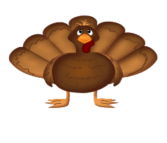  This Photo by Unknown Author is licensed under CC BY | This Photo by Unknown Author is licensed under CC BY

