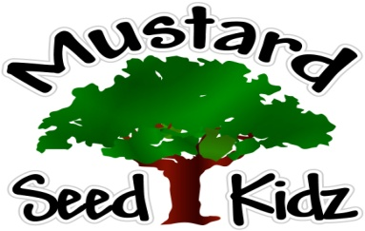
December 3rd – 7th
Breakfast | Monday | Tuesday |  | Wednesday | Thursday | Friday
 | Cheerios  Fruit Cocktail  Milk | Scrambled eggs  Toast  Milk |  | Rice Crispy  Applesauce  Milk | Mini Bagel  w/ Cream Cheese  Mandarin Oranges  Milk | KIx  Bananas  Milk
Lunch | Chicken Nuggets  Mashed Potatoes  Peaches  Milk |  | Corn Dog  Tater Tots  Mixed Vegetables  Fruit Cocktail  Milk | Mexican chicken Casserole  Corn  Pears  Milk | Sweet and Sour Meatballs  Pineapple  Stir fry Vegetables  Milk | Pepperoni Pizza  Salad  Peaches  Milk
Snack | Tortilla Chips  Salsa | String Cheese & Crackers |  | Chex Mix  Raisins | Goldfish  Wheat Thins | Graham Crackers  Apple Juice

