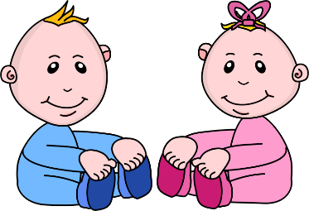
Infant room Lesson plan
Date: December 10th-14th
Teachers: Ms. Amanda, Ms. Carmen, Ms. Skylure, Mrs. Donna
Bible verse: “Love each other” (John 15:17)
I am learning about me
Books  Reading books on a quilt: spread out a blanket and gather books. Allow them to look at books on the blanket. Read to them as they look. | Motor Development  Fun with fill and dump toys: Gather shape sorters, empty buckets and small toys. Help the babies place the toys in the buckets and show them how to dump the out. Repeat.
Art  Painting with sponges: Gather different shaped sponges and help children to paint on colored paper. Allow the children to stamp the pages as often as possible. | Music  Choosing musical instruments: Gather different types of baby appropriate musical instruments and allow them to choose and instrument that they want, sing and play up beat music.
Nature:  Observing Goldfish: Get a small bowl of water and place a couple of the plastic goldfish in it. Using descriptive language, tell the children about the fish. Where it lives, what it eats, etc. | Toys  Fun with a ball: Gather a small basket of balls and empty basket. Show the babies how to toss the balls into the empty hamper, allow them to pour out.

