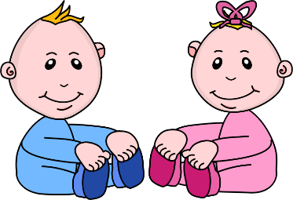
Infant room Lesson plan
Date: December 3rd-7th
Teachers: Ms. Amanda, Ms. Carmen, Ms. Courtney, Mrs. Donna
Bible verse: “God made all things” (John 1:3)
I am learning about me
Books  Bible box: print some pictures of Jesus from the baby bible. Place the bible in a brightly colored box in the play area. Help the babies open and discover the bible. | Motor Development  Hear a rattle: Shake a rattle beside a child’s head and continue until they turn their head to look for the sand. Thank God for ears to hear and repeat on the other side of the child’s head.
Art  Sponge painting: Get a sponge and help the babies stamp them on the paper. Tell them the shapes and colors as you go. | Music  Songs about me: Play “this little piggy” with a child that is laying on the activity mat. Next sing “Twinkle twinkle, little star”
Nature:  Texture mat: Make a texture mat by sticking several pictures onto the floor with contact paper. Let the babies discover the pictures and describe the pictures to them as they go. | Toys  Discovery bottle: Cut brightly colored straws into many small pieces and place in a bottle. Glue the bottle shut and encourage the babies to shake it.

