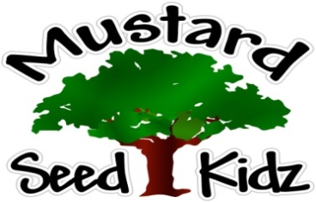
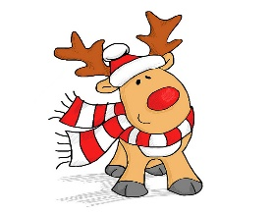
This Photo by Unknown Author is licensed under CC BY
December 10th – December14th
Breakfast | Monday | Tuesday |  | Wednesday | Thursday | Friday
 | Cheerios  Applesauce  Milk | Pancakes  Mandarin Oranges  Milk |  | Corn Flakes  Fruit Cocktail  Milk | Fruit Bar  Peaches  Milk | Kix  Bananas  Milk
Lunch | Chicken Nuggets  Sweet Potato Fries  Green Beans  Milk |  | Ham and Cheese Sandwich  Corn  Pears  Milk | Sheppard’s Pie Mashed Potatoes  Mixed Vegetables  Peaches  Milk | Baked Ziti  Broccoli  Pineapple  Milk | Chicken Salad Wrap  Carrots  Applesauce  Milk
Snack | Pretzels  Cheese | String Cheese & Crackers |  | Chex Mix  Raisins | Tortilla Chips  Salsa | Strawberry Bread  Apple Juice

