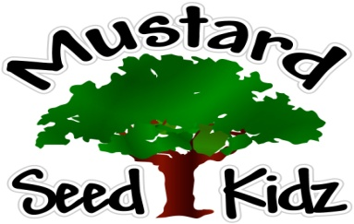
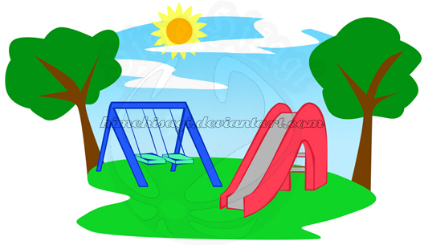
February 4th-8th
Breakfast | Monday | Tuesday |  | Wednesday | Thursday | Friday
 | Cheerios  Applesauce  Milk | Pancakes  Fruit Cocktail  Milk |  | Rice Crispies  Applesauce  Milk | Cereal bar  Peaches  Milk | Kix  Pineapple  Milk
Lunch | Chicken Nuggets  Green Beans  Fruit Cocktail  Milk |  | Italian Chicken  Yellow Rice  Broccoli  Peaches  Milk | Beef Ravioli  Corn  Pears  Milk | Turkey & Cheese  Sandwich Sweet Potato Fries  Pineapple  Milk | Kielbasa  Buttered Egg Noodles  Peas& Carrots  Pineapple  Milk
Snack | Gold Fish  Sliced Cheese | Chex Mix  Raisins |  | Pretzels  Applesauce | Multi Grain Crackers  String Cheese | Apple Juice  Blueberry Muffin Bread

