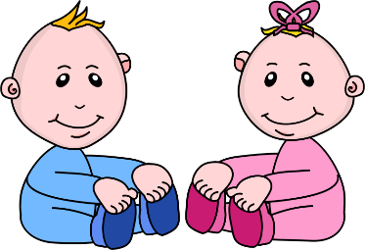
Infant Room Lesson Plan
Date: Monday February 11th – Friday February 15th
Teachers: Ms. Cici, Ms. Carmen, Ms. Sky, Mrs. Donna, Ms. Camisha
Bible verse: “God gave us eyes to see” (Proverbs 20:12)
Books  Discovering books: Locate several favorite books from the class. Lay them on the floor and cover them partially with a towel. Place them around the room for babies to discover. | Motor Development  Looking in the mirror: Give the babies dress up hats to put on. When they have them on show them their reflection in a child safe mirror.
Art  Water painting: Help the children paint on a piece of paper. Read a bible story while they paint. | Music  Where’s the toy? : Hide a few musical toys under a blanket. Encourage the children to search for the musical toys. Praise them when they succeed.
Nature:  Taking a walk: Put the kids in the buggy and take them for a walk outside. Describe everything you see along the way and once you get outside, taking care to explain God created everything. | Toys  Playing with animals: place several plastic animals in the mobile area. Use bible thoughts, songs and ideas to talk to the children about the animals and what they do.

