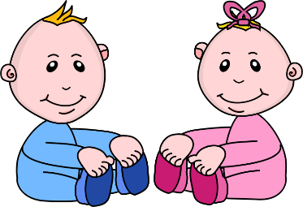
Infant Room Lesson Plan
Date: Monday February 4th- Friday February 8th
Teachers: Ms. Cici, Ms. Carmen, Ms. Sky, Mrs. Donna, Ms. Camisha
Bible verse: “God gave us ears to hear” (Proverbs 20:12)
Books  Things I can do: Gather books that depict toddler’s lives and skills. Babies will enjoy hearing books about things they know. Read individually as they show interest in the basket of books. | Motor Development  Clapping our hands: Sit with a group of children. Start singing if you’re happy and you know it and show them how to clap their hands. Thank god for our hands.
Art  Finger play in the paint: Get a piece of paper and put dots of different colored paint. Have the children touch the paint and play in it to create art on their paper. | Music  Pulling a musical toy: Have the children grab the xylophone by the string and pull it. Also show them that it makes music and show them how to do it.
Nature:  Feeling a cold, squishy bag: pour water and food coloring into a bag. Freeze it half way so that it’s still a little squishy but cold. Let the children touch it. Describe to them what they are feeling. | Toys  Putting blocks in a box: Get a large container box and place blocks inside. Help the children put the blocks in and take them out of the box.

