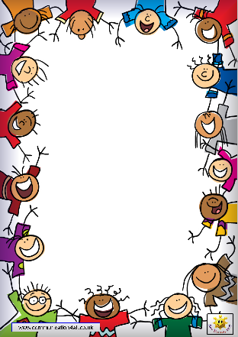
Terrific Twos
This Photo by Unknown Author is licensed under CC BY-NC-ND

Week Of: February 11th-15th, 2019 Lesson: We Have Fun with Friends
Bible Verses: “Jesus had friends” (Luke 2:52)
Color: Red Number: 2 Shape: Heart Letter: Bb Spanish: Amor
Week Of: February 11th-15th, 2019 Lesson: we have fun with friends  Bible Verses: “Jesus had friends” (Luke 2:52) Color: Red Number: 2 Shape: Heart Letter: Bb Spanish: amor | Monday | Tuesday | Wednesday | Thursday | Friday
Art | Painting at the easel | Painting at the easel | Making fingerprint designs | Making fingerprint designs | Painting with an eyedropper
Books & Listening | Reading with friends | Reading with friends | Sharing a friend’s picture album | Sharing a picture album | Preparing a center
Block Center | Going on a safari | Going on a safari | Playing with friends | Playing with friends | Having fun with large cardboard box
Home Living | Playing with water | Playing with water | Sorting silverware | Valentine’s day party | Sorting silverware
Music | Playing classical music | Playing classical music | Singing songs | Singing songs | Playing music outside
Puzzles/ Manipulatives | Working wooden puzzles | Working wooden puzzles | Matching and sorting | Matching and sorting | Lacing cards
Kindness Curriculum: Jewel Floats | Collecting bottles | Group sink or float activity & Prediction Chart | Gathering items for our Jewel Float bottles | Creating our Jewel Float bottles | Kindness Curriculum Review

