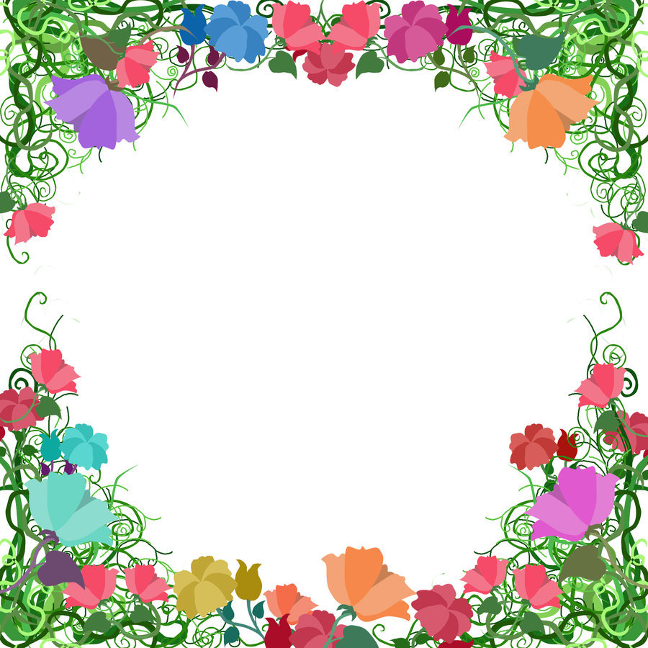
Terrific Twos

Week Of: February 18th-22nd, 2019 Lesson: We Thank God for Plants
Bible Verses: “God made the birds” (Genesis 1:21) Color: Red Number: 2 Shape: Heart Letter: Bb Spanish: Amor
Week Of: February 18th-22nd, 2019 Lesson: we thank god for plants  Bible Verses: “God made the birds” (Gen.1:21) Color: Red Number: 2 Shape: Heart Letter: Bb Spanish: amor | Monday | Tuesday | Wednesday | Thursday | Friday
Art | MSK | Sponge painting leaves | Sponge painting leaves | Playing with playdough | Playing with playdough
Books & Listening | Will be | Looking at the bible and flowers | Looking at the bible and flowers | Looking at a book about trees | Looking at a book about trees
Block Center | Closed | Playing with a toy wheel barrel | playing with a toy wheel barrel | playing with branches | Playing with branches
Home Living | Enjoy your | Arranging flowers | Arranging flowers | Wearing sunglasses | Wearing sunglasses
Music | Holiday | Singing with a visitor | singing with a visitor | Looking at the bible and singing | Looking at the bible and singing
Puzzles/ Manipulatives | Weekend | Working wooden puzzles | Working wooden puzzles | Playing with a wall puzzle | Playing with a wall puzzle
Kindness Curriculum: |  | Acts of Kindness | Acts of Kindness | Acts of Kindness | Acts of Kindness

