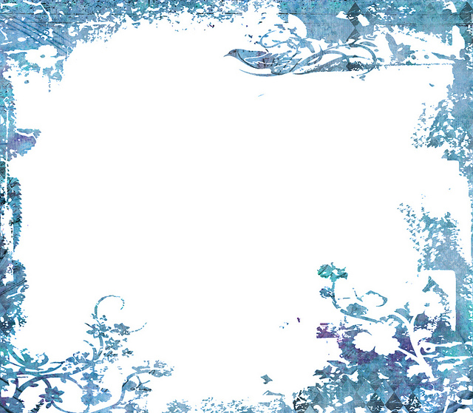
This Photo by Unknown Author is licensed under CC BY-NC
Terrific Twos
Week Of: February 25th-March 1st, 2019 Lesson: We Thank God for Water
Bible Verses: “God made the water” (Psalm 104:10)
Color: Red Number: 2 Shape: Heart Letter: Bb Spanish: Amor

 | Monday | Tuesday | Wednesday | Thursday | Friday
Art | Painting with water | Painting with water | Painting with sponges | Painting with sponges | Yarn painting
Books & Listening | Reading books about rain | Reading books about rain | Reading books about fishing | Reading books about fishing | looking at books about water
Block Center | Playing with toy farm animals | playing with toy farm animals | playing with toy boats | playing with toy boats | playing with toy zoo animals
Home Living | Washing dolls | Washing dolls | Washing doll clothes | Washing doll clothes | Cleaning and tasting fresh fruit
Music | Listening to songs about rain | Listening to songs about rain | Listening to sounds of items in water | Listening to sounds of items in water | Singing songs about rain
Puzzles/ Manipulatives | Puzzles about water | Puzzles about water | working puzzles about riding in a boat | Working puzzles about riding in a boat | Working water puzzle
Kindness Curriculum: Love | Acts of Kindness | Acts of Kindness | Acts of Kindness | Acts of Kindness | Acts of Kindness

