Blessed Two’s Lesson Plan
Week of: February 4th - February 8th,2019
Lesson of the Week: We Discover Zoo Animals
Bible story(s): Noah Cared for the Animals (Genesis 6:9-10)
Color: Brown Shape: Oval Number: 2 Letter : Zz
 | MONDAY | TUESDAY | WENDESDAY | THURSDAY | FRIDAY
Art | Making Paw Prints | Making Paw Prints | Painting with Feathers | Painting with Feathers | Drawing with Crayon Chunks
Block Center | Matching Zoo Animals | Matching Zoo Animals | Sharing Noah’s Story | Sharing Noah’s Story | Listening and Learning
Books & Listening | Setting Up a Zoo Library | Setting Up a Zoo Library | Identifying Zoo Animals | Identifying Zoo Animals | Rhyming and Laughing
Home Living | Doctoring the Animals | Doctoring the Animals | Making Honey Bear Snacks | Making Honey Bear Snacks | Arranging Flowers
Music Center | Enjoying Music with Puppets | Enjoying Music with Puppets | Singing about Animal Actions | Singing about Animal Actions | Playing a Kazoo in a Zoo Band
Nature  Center | Roaring as we Walk | Roaring as we Walk | Huffing and Puffing | Huffing and Puffing | Going on a Safari
Puzzles  &  Manipulatives | Matching Pictures and Animals | Matching Picture and Animals | Peeking at the Animals | Peeking at the Animals | Solving Post Card Puzzles
Kindness Curriculum | Let's Talk about Respect | 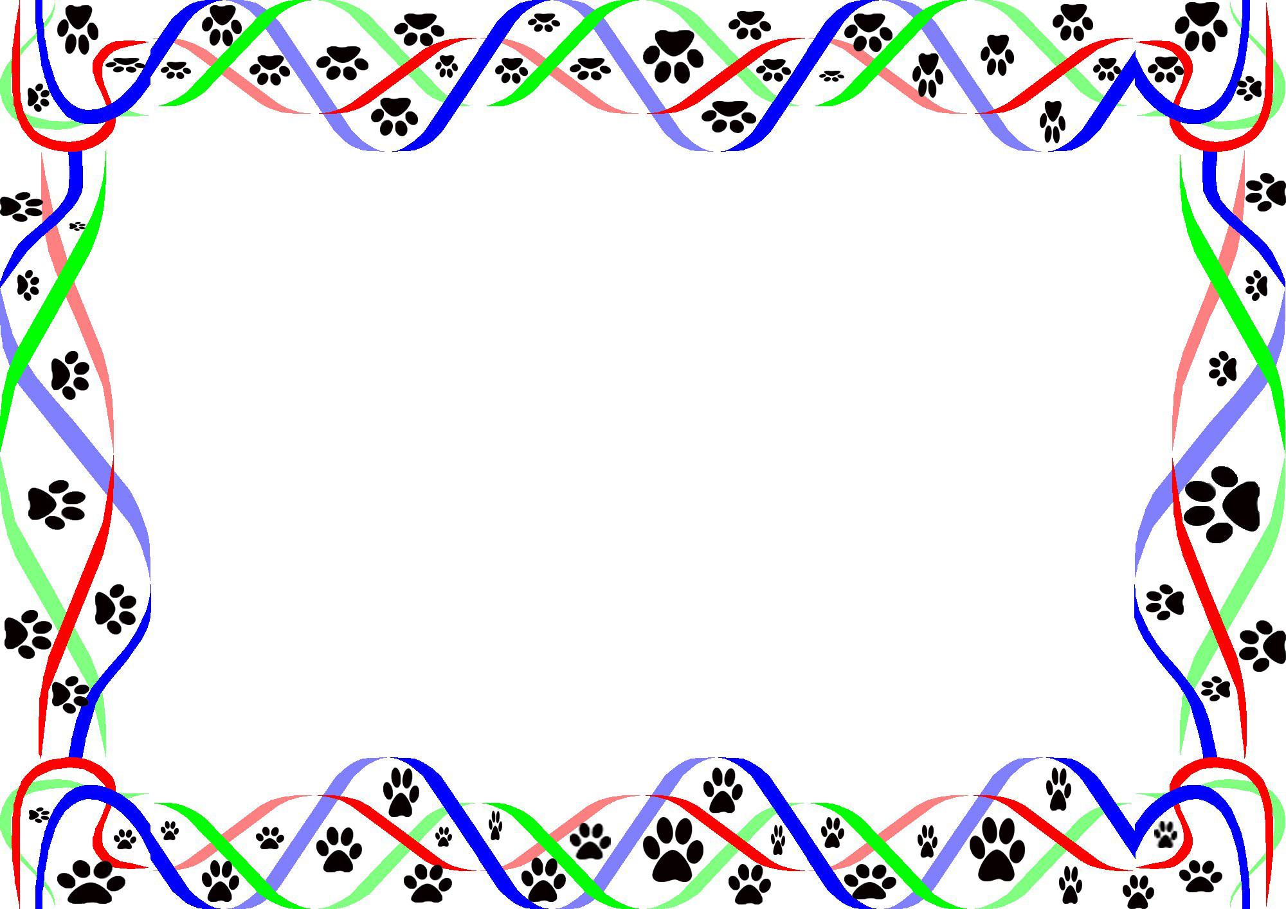  Let's Talk about Respect  This Photo by Unknown Author is licensed under CC BY-SA | Polite or Impolite | Polite or Impolite | Review Respect

