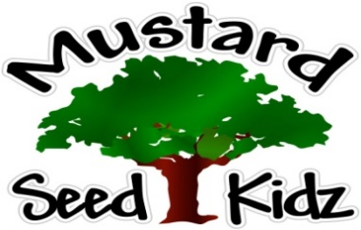
February 11th -15th
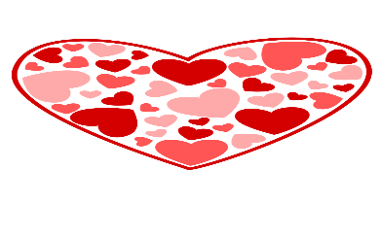
Breakfast | Monday | Tuesday |  | Wednesday | Thursday | Friday
 | Cheerios  Banana slices  Milk | Scrambled Eggs  Peaches  milk |  | Kix  Fruit Cocktail  Milk | Waffles  Apple sauce  Milk | Corn Flakes  Pineapple  Milk
Lunch | Chicken Nuggets  Mashed Potatoes  Pears  Milk |  | Spaghetti with meat sauce  Salad  Applesauce  Milk | Hot Dog on a bun  Pickles  Fruit Cocktail  Milk | Macaroni and cheese with Ham  Green Beans  Mandarin Oranges  Milk | Chicken Fettuccini Alfredo  With broccoli  Peaches  Milk
Snack | Tortilla Chips  Salsa | Chex Mix  Cranberries or Raisins |  | Wheat Thins  Pepperoni Slices | Pretzels  String Cheese | Oatmeal Bar Muffin  Apple Juice

