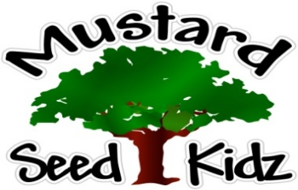
February 18th -22nd
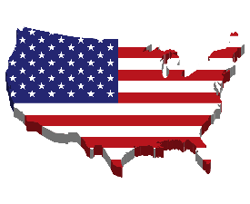
Breakfast | Monday | Tuesday | Wednesday | Thursday | Friday
 | MSK Closed | Bagel w/ Cream Cheese  Peaches  Milk | Rice Crispy  Fruit Cocktail  Milk | Kix  Banana Slices  Milk | Pancakes  Pineapple  Milk
Lunch | In Observance  of | Sweet and Sour Meatballs  Egg Noodles  Peas & Carrots  Pears  Milk | Mexican Chicken Casserole  Corn  Pineapple  Milk | Corn Dog  Green Beans  Peaches  Roll  Milk | Hot Ham & Cheese Sandwich  Pickles  Fruit Cocktail  Milk
Snack | Have a safe Holiday | String Cheese  Pretzels | Chex Mix  Raisins | Cheese & Crackers | Graham Crackers  Milk

