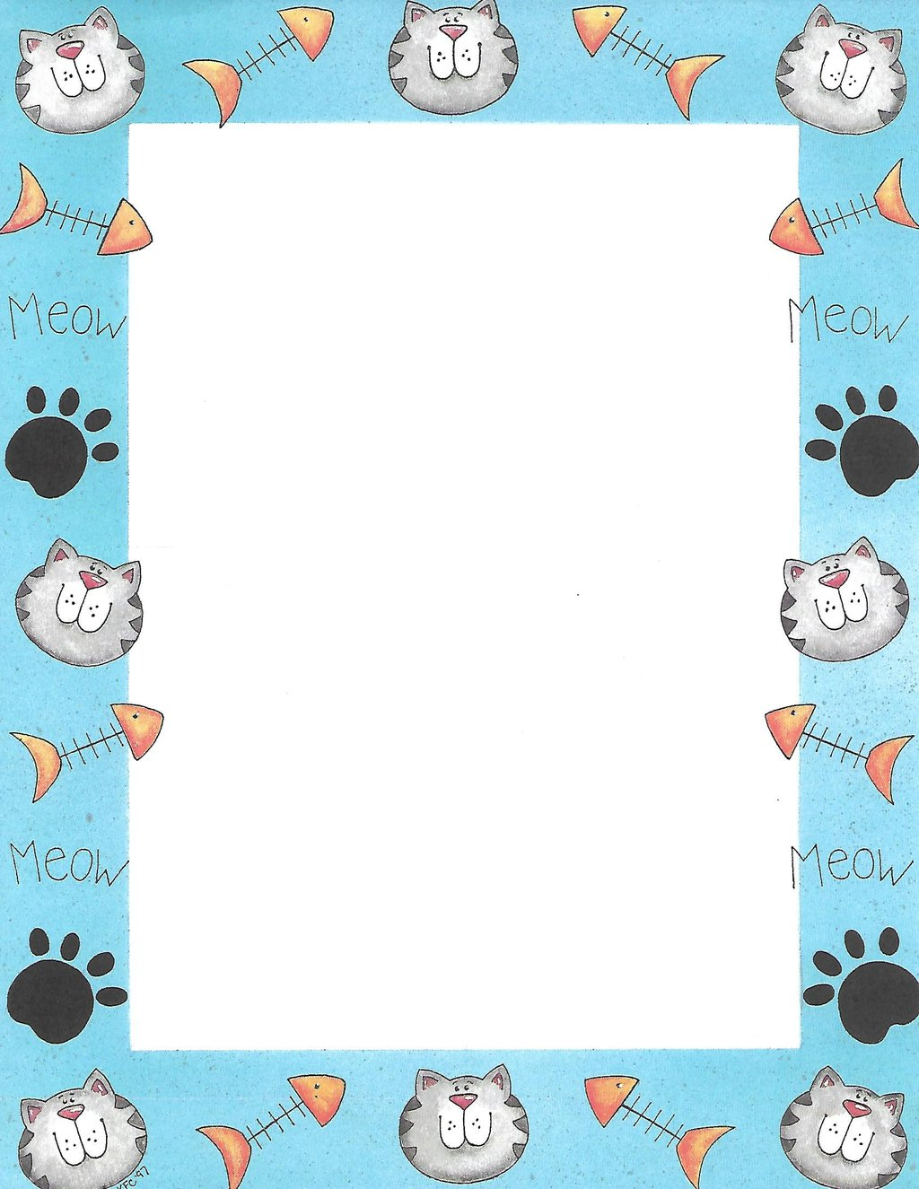
This Photo by Unknown Author is licensed under CC BY-SA-NC
Terrific Threes & Fours
Week of: February 18th-22nd m Lesson: Pets Need Care
Bible Verses: Adam Names the Animals (Genesis 1:20, 2:19-20)
Letter: Tt Number: 13 Color: Yellow Shape: Diamond
Spanish: Purple - Morado Sign Language: I love you
The purpose of this lesson is to help children become more aware of various kinds of pet; to learn that pets need food, water, exercise and a place to live; and to realize that God planned for animals.
Date: Feb 18th-22nd | Monday | Tuesday | Wednesday | Thursday | Friday
Art | Stamping with animal cookie cutters | Creating a tube bunny | Painting over glue | Drawing with multiple crayons | Making a fish bowl
Nature | Observing goldfish | Feeling textures | Identifying pet homes | Planting carrot tops | Looking at birds through the window
Books & Listening | Making a class pet book | Playing with animal puppets | Listening to pet sounds | Making animal sounds | Looking at pet pictures
Blocks | Playing with [plastic animals | Setting up a pet store | Weighing blocks | Identifying shapes | Building a zoo
Music | Singing and moving | Playing hide and seek with musical cues | Pretending to swim like fish | Singing a rebus song | Listening and moving
Writing | Coloring the letter of the week | Coloring the number of the week | Tracing the letter of the week | Tracing the number of the week | Tracing names
Home Living | Feeding pets | Visiting the vet | Enjoying a pet show | Caring for kittens | Washing animal toys
Kindness Curriculum:  Hug a Bug | Having fun dancing to music | Encouraging friendships | Hugging our friends | Musical hug dance activity | Kindness Curriculum Review

This Photo by Unknown Author is licensed under CC BY-NC-ND

