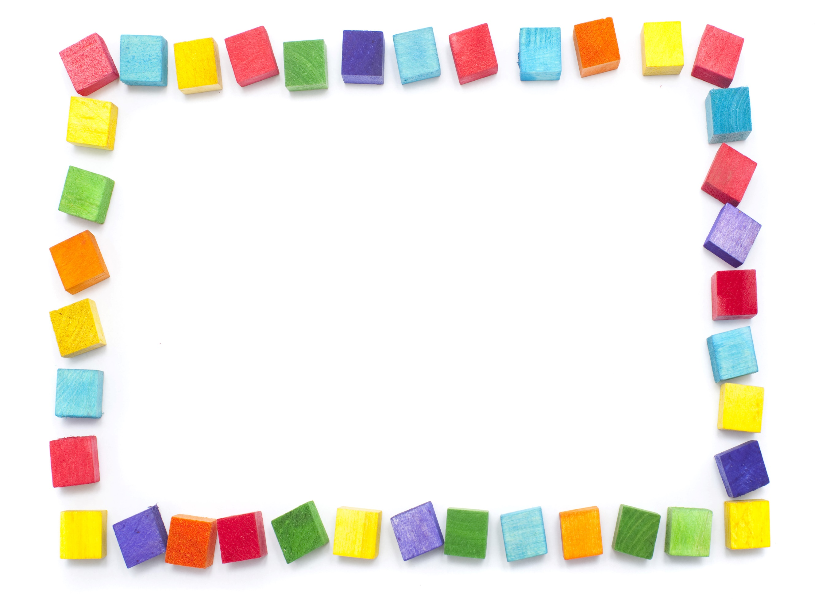
This Photo by Unknown Author is licensed under CC BY
Terrific Threes & Fours
Week of: February 7th-11th Lesson: I Have Favorite Toys
Bible Verses: Be kind to one another (Ephesians (4:32) & God made me (Psalms 119:73)
Letter: Rr Number: 1 Color: Black Shape: Triangle Spanish: Toy Sign Language: Please
The purpose of this unit is to give children opportunities to use and talk about their favorite toys and help them become aware of the kinds of toys Jesus might have played with when he was a child.
Date: Feb 7th-11th | Monday | Tuesday | Wednesday | Thursday | Friday
Art | Making toys | Painting with toys | Making wind toys | Pasting pictures of toys | Making paper bag puppets
Nature | Using bathtub toys | Lining up toys | Weighing toys | Observing windup toys | Show & Tell bring your toy to school
Books & Listening | Listening to books about toys | Looking at toy catalogs | Telling a story with a puppet | Enjoying a wordless picture book | Reading about toy bears
Blocks | Enjoying unit blocks | Playing toy store | Playing with vehicles | Using paper towel tubes | Building a house for a toy
Music | Making a hand instrument | Using a rhythm instrument | Pretending to be toys | Musical chairs | Head & shoulders knees and toes song
Writing | Coloring the letter of the week | Coloring the number of the week | Tracing the letter of the week | Tracing the number of the week | Tracing names
Home Living | Shopping for toys | Playing with handmade toys | Having a tea party | Wash toy dishes | Wrap dolls with a blanket
Kindness Curriculum:  Polite or Impolite | Learn about different behaviors | Being polite and impolite to our dolls | Saying thank you & no thank you | Discuss definition of polite | Kindness curriculum review

