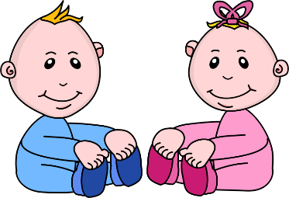
Infant Room Lesson Plan
Date: Monday April 29th – Friday May 3rd 2019
Teachers: Ms. Cici Ms. Carmen, Ms. Kaylee, Mrs. Camisha
Bible verse: “God gave us eyes to see” (Proverbs 20:12)
I Can See and Hear
Books  Discovering books: locate several favorite books from the class. Lay them on the floor and cover | Motor Development  Shape can: Use a clean formula can to make a shape can. Cut a hole in the top of the can and drop golf balls in the hole. Talk about shapes and colors.
Art  Handprints: use soft colors of construction paper and dark colors of crayons to trace handprints. Sing to the children as you trace hands. | Music  Name song: Sing the song “I am Happy” to each child as they come into the room, using their names. Show them their reflections in the mirror.
Nature:  Bird feeder: Place a bird feeder in a tree at eye level to the baby buggy. Take the children outside to look at the bird feeder. | Toys  Using soft blocks: Gather all of the soft blocks and stack them into a tower. Help the babies stack the tower and knock it down repeatedly.

