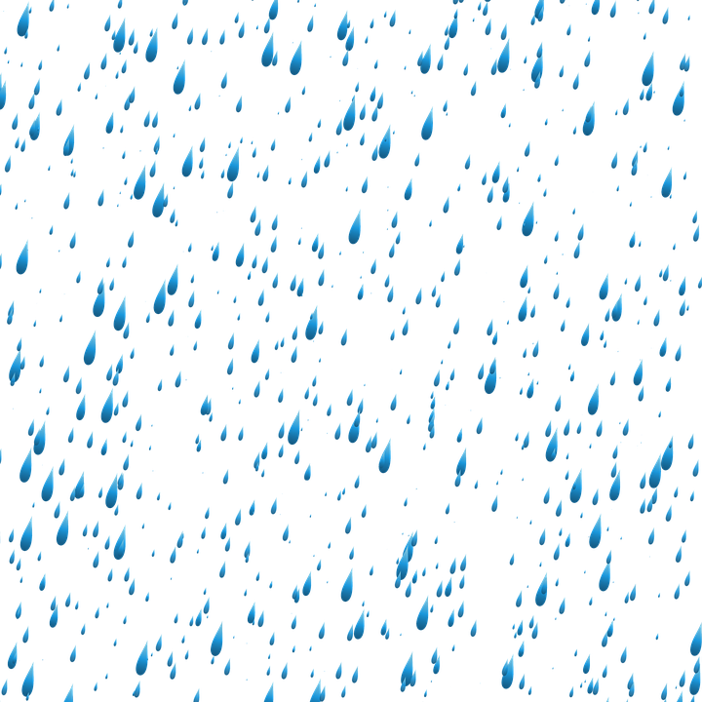
Blessed Two’s Lesson Plan
Week of: April 29th - May 3rd, 2019
Lesson of the Week: We Thank God for Water
Bible story(s): God Made Water (Genesis 1:6-7)
Color: Blue Shape: Rectangle Number: 6 Letter : Ww
 | MONDAY | TUESDAY | WENDESDAY | THURSDAY | FRIDAY
Art | Painting with Water | Painting with Water | Mixing Dry Tempra Paint with Water | Mixing Dry Tempra Paint with Water | Painting with Plastic Droppers
Block Center | Playing with Farm Animals | Playing with Farm Animals | Playing with Toy Boats | Playing with Toy Boats | Playing with Zoo Animals
Books & Listening | Reading a Book About Rain | Reading a Book About Rain | Looking at Books about Water | Looking at Books about Water | Reading Books about Fishing
Home Living | Washing Dolls | Washing Dolls | Washing Doll Clothes | Washing Doll Clothes | Cleaning and Tasting Fresh Vegetables
Music Center | Listening to Songs about Rain and Water | Listening to Songs about Rain and Water | Listening to Sounds of Items in Water | Listening to Sounds of Items in Water | Singing Songs about Rain and Water
Nature  Center | Playing with Items that Sink or Float | Playing with Items that Sink or Float | Caring for Fish | Caring for Fish | Planting Seed
Puzzles  &  Manipulatives | Working a Water Puzzles | Working a Water Puzzles | Working Puzzles about Water and Rain | Working Puzzles about Water and Rain | Working Puzzles about Use of Water
Kindness Curriculum | Talk About Gentleness | Bathing Babies | Bathing Babies | Feather Play | Review Gentleness

