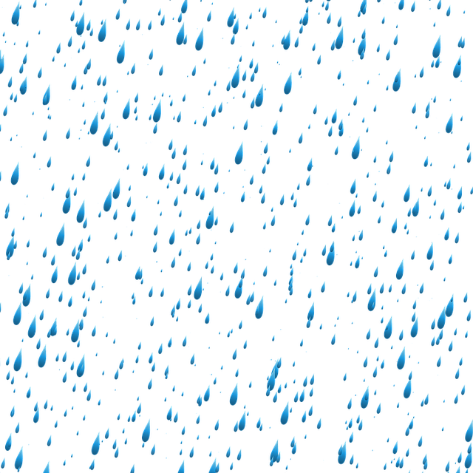
Blessed Two’s Lesson Plan
Week of: May 6th- May 10th, 2019
Lesson of the Week: We Thank God for Water
Bible story(s): God Made Water (Genesis 1:6-7)
Color: Blue Shape: Rectangle Number: 6 Letter : Ww
 | MONDAY | TUESDAY | WENDESDAY | THURSDAY | FRIDAY
Art | Painting with Sponges | Painting with Sponges | Painting with Yarn | Painting with Yarn | Painting with Soap Paint
Block Center | Playing with Farm Animals | Playing with Farm Animals | Playing with Toy Boats | Playing with Toy Boats | Playing with Zoo Animals
Books & Listening | Reading a Book About Rain | Reading a Book About Rain | Looking at Books about Water | Looking at Books about Water | Reading Books about Fishing
Home Living | Washing Dolls | Washing Dolls | Washing Doll Clothes | Washing Doll Clothes | Cleaning and Tasting Fresh Fruit
Music Center | Listening to Songs about Rain and Water | Listening to Songs about Rain and Water | Listening to Sounds of Items in Water | Listening to Sounds of Items in Water | Singing Songs about Rain and Water
Nature  Center | Tasting Warm and Cold Water | Tasting Warm and Cold Water | Watering Plants | Watering Plants | Blowing Bubbles
Puzzles  &  Manipulatives | Working a Water Puzzles | Working a Water Puzzles | Working Puzzles about Water and Rain | Working Puzzles about Water and Rain | Working Puzzles about Use of Water
Kindness Curriculum | Balloon Pals | Balloon Pals | Self-Control | Self-Control | Polite or Impolite

