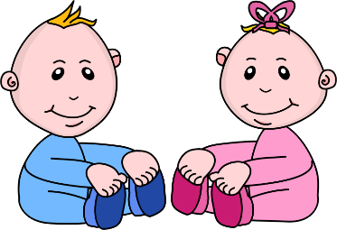
Infant Room Lesson Plan
Date: Monday May 13th- Friday May 17th 2019
Teachers: Ms. Cici, Ms. Carmen, Mrs. Camisha, Ms. Kaylee
Bible verse: “God made people” (Genesis 1:27)
I can taste, touch, and smell
Books  Making a feel book: Find different textured fabrics to use as pages for a textured book. | Motor Development  Hear a rattle: shake a rattle on the right side of a child’s head. After they turn their head, shake the rattle on the other side, and wait for the child to turn their head. Say, “Thank you God, for letting us hear sounds.”
Art  Handprint tree: Get a big piece of white paper. Draw or paint a tree trunk onto the bottom of the paper. Use the children’s hands and green paint to make the rest of the tree. Tell the children “God made the trees” | Music  Making music: make several musical shaker toys by placing bells and curly, colorful ribbon inside water bottles and hot glue shut. Place the shakers on the floor and encourage children to make music.
Nature:  Bubbles: during the outside time, take bubbles onto the mat. Sing the “bubble song” as you talk about the colors in the bubbles. Tell the children about wind outside. | Toys  Rattle mobile: Make a mobile out of yarn and rattles and suspend from the ceiling. Hold the children and show them the rattles, using many descriptive words as you talk.

