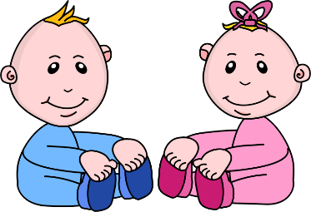
Infant Room Lesson Plan
Date: Monday May 20th- 24th 2019
Teachers: Ms. Cici , Ms. Carmen, Ms. Camisha, Ms. Kaylee
Bible verse: “God made me” (Psalm 139:14)
Toys for play
Books  Looking at books: Gather two tote bags, rattles, and a couple books. Place a book and a rattle in each bag. Lay the tote bags on the floor for the babies to discover. As they find the bags, read to the babies and show them how to shake the rattles. | Motor Development  Kicking: Tie the large jingle bells to a piece of yarn and tie loosely around the baby’s ankle. Help guide the baby to kick their feet and make the bells jingle.
Art  Coloring: Gather a couple colorful big crayons and a piece a paper, hand the child the crayon and let them color the paper. If they are too little to do it by themselves, guide their hand along the paper. | Music  Listening to sounds: Hang several rattles from the bottom of a crib. Place jingle bells in a baby bottle and secure the lid. Encourage the babies to share the bottle and kick the rattles.
Nature:  Looking at rocks: Make an infant-safe discovery bottle by placing small rocks inside a clear plastic bottle. Secure the bottle closed with hot glue. Let the babies explore the bottle. | Toys  Playing with toys: select toys that can be attached to elastic, such as rattles, inflatable balls or infant keys. Hang the toys with the elastic to the bottom of cribs. Encourage the children to play with the toys.

