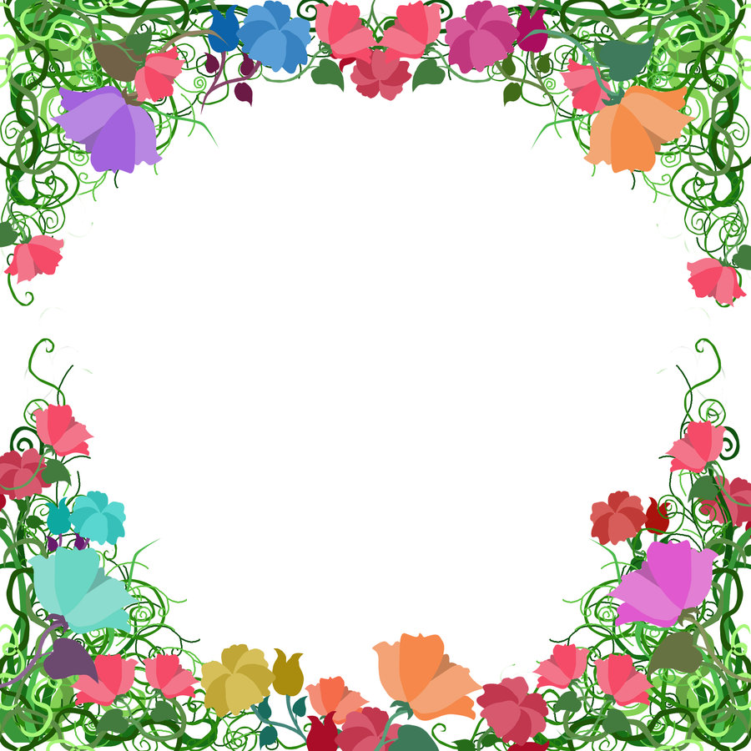
This Photo by Unknown Author is licensed under CC BY
Blessed Two’s Lesson Plan
Week of: August 27th – August 31st, 2019
Lesson of the Week: We Thank God for Plants
Bible story(s): God made flowers (Matt. 6:28-31)
Color: Green Shape: Triangle Number: 5 Letter : Pp
 | MONDAY | TUESDAY | WENDESDAY | THURSDAY | FRIDAY
Art | Sponge Painting with leaves | Sponge Painting with leaves | Playing with Play-doh | Playing with Play-doh | Finger Painting
Nature and Science | Looking at Books about plants | Looking at Books about plants | Looking at plants and the Bible | Looking at plants and the Bible | Talking about Different plants
Books & Listening | Looking at the Bible and Plants | Looking at the Bible and Plants | Looking at books about Trees | Looking at books about Trees | Reading a book about Trees
Block Center | Playing with Plastic Garden tools | Playing with Plastic Garden tools | Looking at Picture and Flower Seed Packages | Looking at Picture and Flower Seed Packages | Playing with a Toy Wheelbarrow
Home living | Arranging Flowers | Arranging Flowers | Washing Dishes | Washing Dishes | Pick Veggies out of the Garden
Music | Singing with A Visitor | Singing with A Visitor | Listening to Song | Listening to Song | Sing your Favorite Song
Puzzles & Manipulatives | Playing with Wall Puzzles | Playing with Wall Puzzles | Playing with teacher made puzzle of placemats | Playing with teacher made puzzle of placemats | Working on a Puzzle with a friend
Kindness Curriculum | Learning about Gentleness | Learning about Gentleness | Feather Play | Feather Play | Dancing Balloons

