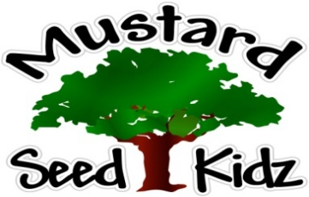
April 15th -19th

Breakfast | Monday | Tuesday |  | Wednesday | Thursday | Friday
 | Cheerios  Applesauce  Milk | Scrambled Eggs  Toast  milk |  | Waffles  Fruit Cocktail  Milk | Corn Flakes  Peaches  Milk | MSK Closed
Lunch | Chicken Nuggets  Mashed Potatoes  Pears  Milk |  | Chili w/  Macaroni (WG)  Green Beans  Fruit Cocktail  Milk | Salisbury Steak  Buttered Noodles  Peaches  Milk | Grilled Cheese  French Fries/or Tater Tots  Pickles  Mandarin Oranges  Milk | IN Observance  Of  Good Friday
Snack | Tortilla Chips  Salsa | Chex Mix  Cranberries or Raisins |  | Pretzels  String Cheese | Wheat Thins  Pepperoni Slices | Have a wonderful Easter  