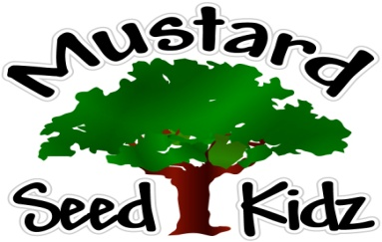
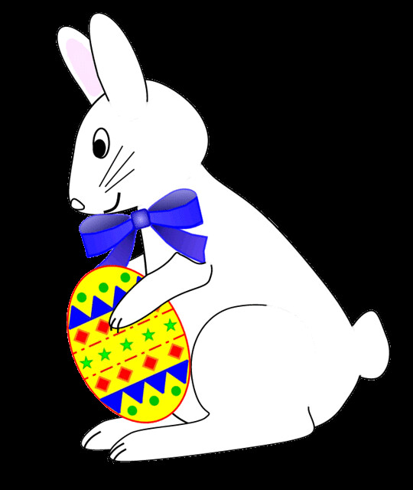
April 22nd – April 26th

Breakfast | Monday | Tuesday | Wednesday | Thursday | Friday
 | Cheerios  Fruit Cocktail  Milk | Bagel w/ Cream Cheese  Peaches  Milk | Rice Crispy  Fruit Cocktail  Milk | Kix  Banana Slices  Milk | Pancakes  Pineapple  Milk
Lunch | Chicken Nuggets  French Fries  Peaches  Milk | Sweet and Sour Meatballs  Egg Noodles  Peas & Carrots  Pears  Milk | Mexican Chicken Casserole  Corn  Pineapple  Milk | Corn Dog  Green Beans  Peaches  Roll  Milk | Hot Ham & Cheese Sandwich  Pickles  Fruit Cocktail  Milk
Snack | Wheat Thins  Oranges | String Cheese  Pretzels | Chex Mix  Raisins | Cheese & Crackers | Graham Crackers  Milk

