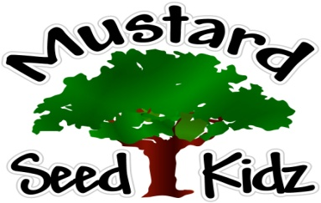
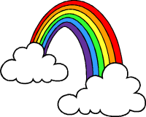
April 8th-12th

Breakfast | Monday | Tuesday |  | Wednesday | Thursday | Friday
 | Corn Flakes  Applesauce  Milk | English Muffin or Mini Bagel  Fruit Cocktail  Milk |  | KIX Cereal  Peaches  Milk | French Toast Sticks  Bananas  Milk | Cheerios  Fruit Cocktail  Milk
Lunch | Chicken Nuggets  French Fries  Mandrin Oranges  Milk |  | Ranch Chicken  Yellow Rice  Peaches  Broccoli  Milk | Sloppy Joes on a Bun  Applesauce  Green Beans  Milk | Beanie Weenies  Pineapple  Cornbread  Mixed Vegetables  Milk | Pepperoni Pizza  Salad  Pears  Milk
Snack | Wheat Thins  String Cheese | Trail Mix  Raisins |  | Cheese &  Crackers | Animal Crackers  Yogurt | Graham Crackers  Milk

