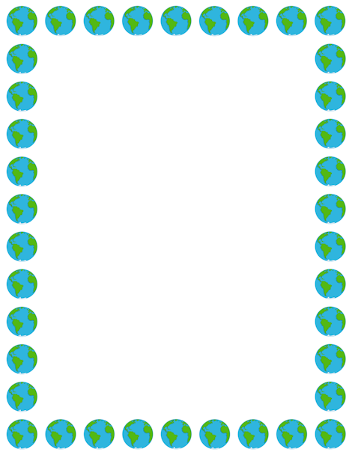
Terrific Three’s & Four’s
Week of: April 22nd – April 26th Lesson: I Can Care for my World
Bible Verse: “Everything God made was very good” (Genesis 1:31)
Letter: Zz Number: 4 Color: White Shape: Star
Purpose: The purpose of this unit is to help children become aware that they can help take care of God’s world.
April 22nd- 25th | Monday | Tuesday | Wednesday | Thursday | Friday
Art | Painting on newspaper | Making a beautiful world mural | Making a trash bag | Coloring with chunk crayons | Making a label collage
Nature | Playing with water | Looking at dirt | Taking care of plants | Recycling food | Using a birdseed sand box
Books & Listening | Listening to books | Making a class book | Looking at Bible pictures | Looking at nature magazines | Making a nature scene book
Blocks | Building with wood scraps | Building with reusable items | Using transportation vehicles | Making cardboard blocks | Building the letter of the week
Music | Using homemade instruments | Dancing with friends | Decorating a drum | Listening to Bible songs | Making shakers
Puzzles & Manipulative | Working puzzles | Sorting buttons | Matching leaves | Designing with yarn | Matching fabric squares
Home Living | Cleaning the center | Making a class quilt | Playing dress-up | Pretending to be garbage men | Making vegetable soup
Writing | Color the letter of the week | Color the number of the week | Tracing the letter of the week | Tracing the number of the week | Tracing/color shape of the week
Kindness Curriculum:  Earth Care | Talk about Earth | What can we do to help? | Plant flowers | Pick up trash | Review what we have learned

