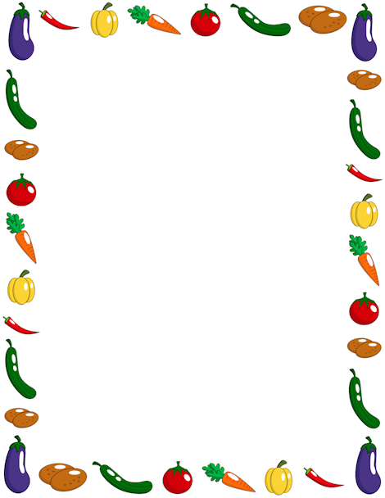
Terrific Three’s & Four’s
Week of: April 29th – May 3rd Lesson: I Can Be Healthy
Bible Verse: “God gives food to us” (Psalms 136:25)
Letter: Vv Number: 7 Color: Orange Shape: Triangle
Purpose: The purpose of this unit is to provide opportunities for children to gain appreciation for their bodies God gave them and to develop an awareness of ways they can help keep their bodies healthy.
April 29th – May 3rd | Monday | Tuesday | Wednesday | Thursday | Friday
Art | Modeling with play dough | Using finger paint | Painting with water | Printing with kitchen tools | Making a mural
Nature | Estimating and counting | Tasting apples | Comparing lengths | Practicing washing hands | Planting carrot tops
Books & Listening | Reading books about being healthy | Using finger puppets | Hearing concept books | Talking about an author | Making folded books
Blocks | Using stand up figures | Stacking cartons | Measuring with blocks | Transporting fruits and vegetables | Building a farm
Music | Moving to music | Exercising with music | Dancing with friends | Doing Yoga | Relaxing with music
Puzzles & Manipulative | Working wooden puzzles | Sorting plastic food | Playing a memory game | Using beads and laces | Sequencing food boxes
Home Living | Washing fruit and vegetables | Playing doctor | Taking a rest | Pouring and drinking water | Measuring and weighing out bodies
Writing | Coloring the letter of the week | Coloring the number of the week | Tracing the letter of the week | Tracing the number of the week | Tracing/color the shape of the week
Kindness Curriculum:  Trash Sort | Talk about sorting items | Discuss what recycling means | Collecting recyclable items | Sorting and recycling | Discuss what we have learned

