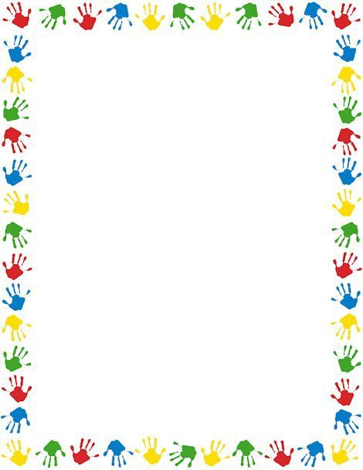
Terrific Threes & Fours
Week of: June 17th–June 21st Lesson: I am Special
Bible Verse: “God made me” (Psalm 139:14)
Letter: Cc Number: 3 Color: Yellow Shape: Square
Purpose: The purpose of this unit is to guide children toward the awareness that God made each of them unique and that they are growing, changing, and becoming more competent each day.
June 17th-21st | Monday | Tuesday | Wednesday | Thursday | Friday
Art | Enjoying finger painting | Pasting facial features | Painting at the easel | Making a handprint mural | Playing with play-doh
Nature | Looking at a skeleton | Weighing and measuring | Comparing eye color | Grouping by association | Sorting shoes
Books & Listening | Hearing about being special | Enjoying a name book | Relating books to experiences | Learning about authors | Listening to story tapes
Blocks | Building with boxes | Playing house | Using stand-up figures | Labeling buildings | Setting up a shoe store
Music | Crawling to music | Singing a Rebus song | Moving to music | Matching voices to pictures | Dancing with friends
Puzzles & Manipulatives | Working wooden puzzles | Making felt faces | Lacing beads | Hearing a Bible story | Learning to Zip, Hook, and Snap
Home Living | Looking in a mirror | Setting the table | Playing with dolls | Playing bedtime | Making dinner
Writing | Coloring the letter of the week | Coloring the number of the week | Tracing the letter of the week | Tracing the number of the week | Tracing/coloring the shape of the week
Kindness Curriculum  Pennies from Heaven | Collecting Pennies all week | Learning about helping at home | Learning about how we can care for others | Counting our pennies together | Kindness Curriculum Review

