JUNE 2019
Monday Tuesday Wednesday Thursday Friday
3  Sea Life & Madame Trussauds  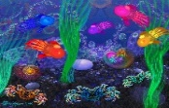  Leave @ 8:00 | 4  Group 1 – Movies & park  This Photo by Unknown Author is licensed under CC BY-NC-ND  Group 2-Park & club  Leave @ 8:30 | 5  Group 1 – Park & club  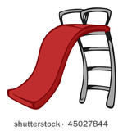  Group 2- Movies & park  Leave @ 8:30 | 6  Malabar Park  Fishing 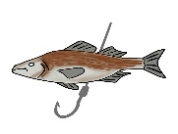  Leave @ 9:30 | 7  Obloy Ranch  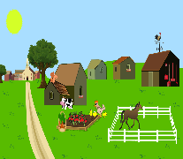  Leave @ 9:00
10  Planet 3  Leave @ 9:15 | 11  Group 1 – Movies & park  This Photo by Unknown Author is licensed under CC BY-NC-ND  Group 2-Pump it up & park  Leave @ 8:30 | 12  Group 1 Pump it up & park  Group 2 Movies & park  Leave @ 8:30 | 13  Crayola Experience  Leave @ 8:15 | 14  Turkey Creek  & Twisty Cone  Leave @ 9:30
17  Rychman Park & fising  Leave @ 9:15 | 18  Group 1 – Movies & park  This Photo by Unknown Author is licensed under CC BY-NC-ND  Group 2-Chuckie Cheese  Leave @ 8:30 | 19  Group 1 Chuckie Cheese  Group 2 Movies & park  Leave @ 8:30 | 20  Park & Art  Leave @ 10:00 | 21  Urban Air  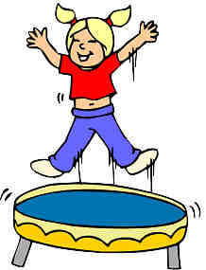  Leave @ 9:00
24  Field of Dreams & Splash Pad  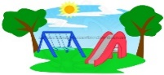  Leave @ 9:00 | 25  Group 1 – Movies & park  This Photo by Unknown Author is licensed under CC BY-NC-ND  Group 2-Park & club  Leave @ 8:30 | 26  Group 1 – Park & club  Group 2- Movies & park  Leave @ 8:30 | 27  Bowling  Leave @ 8:30 & 12:30 | 28  Wild Florida airboat rides  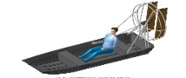  Leave @ 8:30

