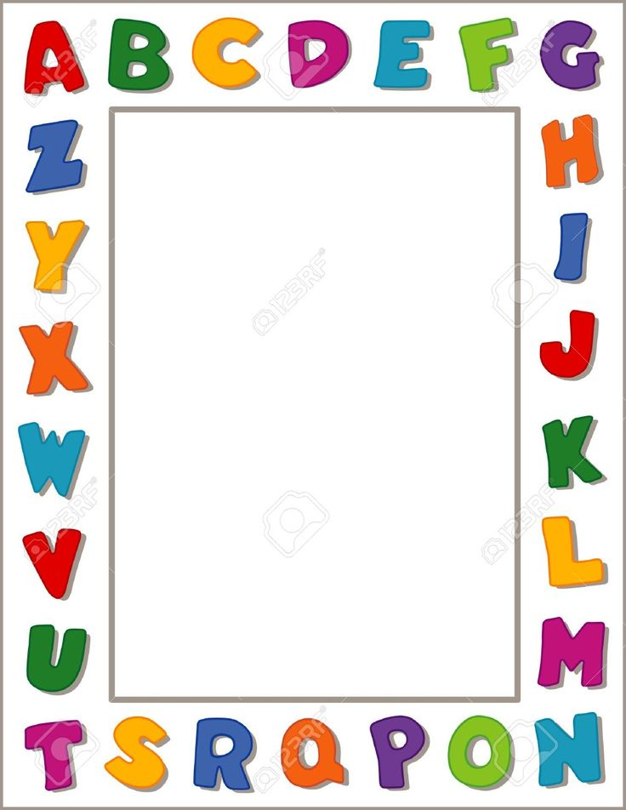
Terrific Threes
Week of: March 2nd–6th Lesson: I Come to Pre-school
Bible Verse: “We work together” (1 Corinthians 1:24).
Letter: Nn Number: 14 Color: red Shape: Circle
Purpose: The purpose of this lesson is to help children develop awareness that school is a happy place where they can enjoy learning and playing with their friends.
 | Monday | Tuesday | Wednesday | Thursday | Friday
Art | Drawing with crayons | Using pencils | Tearing paper | Painting at the easel | Rubbing with crayons
Nature | Caring for plants | Sorting red items | Caring for classroom pets | Observing cuttings root | Keeping our centers neat
Books & Listening | Making a book about school | Learning about concepts | Taking care of books | Reading about a favorite charactor | Hearing about school
Block | Stacking blocks | Building our preschool | Taking care of books | Using stand up figures | Using toy vehicles
Music | Listening to quite music | Using a tape player | Keeping the centers neat | Singing about school | Clapping along with music
Writing | Coloring the letter of the week | Coloring the number of the week | Tracing the letter and number of the week | Practicing writing our names | Doing a worksheet
Home Living | Cleaning a center | Preparing a snack | Looking at catalogs | Playing dress-up | Writing messages
Kindness Curriculum:  Friendship Fruit Soup | Playing in small groups | Working together =to complete an obstacle course | Taking turns with friends | Making Friendship Fruit Soup | Review of what we have learned

