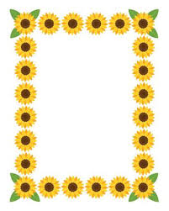
Terrific Threes
Week of: March 9th-13th Lesson: I Learn Through My Senses
Bible Verse: “God is good to us” (Psalm 73:1)
Letter: Oo Number: 15 Color: Green Shape: Square
Purpose: The purpose of this lesson is to provide opportunities for children to use their senses and to develop an awareness that the ability to see, hear, small, touch, and taste are gifts from god.
 | Monday | Tuesday | Wednesday | Thursday | Friday
Art | Painting at the easel | Drawing on sandpaper | Painting with ice | Making and using pumpkin playdough | Finger painting to music
Nature | Pouring water | Taking a walk | Looking through color tubes | Exploring pumpkin seeds and guts | Tasting and describing foods
Books & Listening | Learning about senses | Hearing car sound | Matching sounds and pictures | Hearing poetry | Listening to concept books
Block | Using bristle blocks | Discovering our senses | Stacking and listening | Building a pumpkin patch | Building towers
Music | Playing instruments | Meeting a musician | Playing the autoharp | Playing the xylophone | Inventing noisemakers
Writing | Coloring the letter of the week | Coloring the number of the week | Tracing the letter of the week | Tracing the number of the week | Tracing our names
Home Living | Measuring oats | Washing dishes | Listening to home sounds | Preparing fruit salad | Making blueberry muffins
Kindness Curriculum:  Gifts | Talking about friendships | Sharing with our friends | Working together | Learning to care about your friends | Making gifts for our friends

