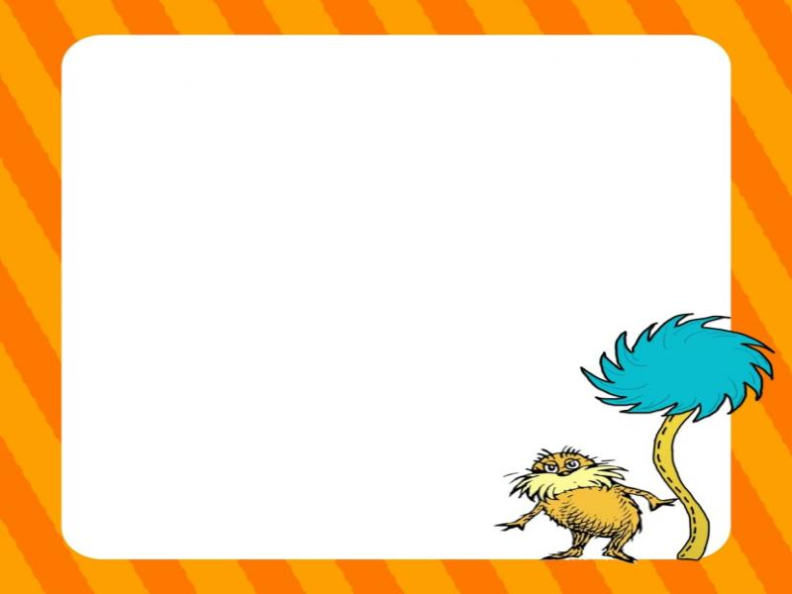
Week of: 3/2-3-6 Theme: Dr. Suess Week Bible Verse: Everything God made was good (Ecclesiastes 3:11)
Letter: Nn Number: 21 Color: Green Shape: Shamrock
Art | Writing | Games/Manipulatives | Books
Painting Patterns  (Cat in the hat) | Hap py Birthday Dr. Suess | Cat’s Hat Cup Stacking | Green Eggs & Ham
The Lorax Mask | Lorax, Lorax What do you see? | Clothespin counting with Dr. Suess | The Lorax
Decorating a sock | Imaginary Character | Colorful Pom Pom drop | Fox in Socks
One fish, Two fish, Red fish, Blue fish | Trace the words and color the fish | Sorting fish and counting goldfish | One fish, Two fish, Red fish, Blue fish
Green eggs and ham | Rhyming “cat” words | Cat’s Hat Toss | Cat in the Hat

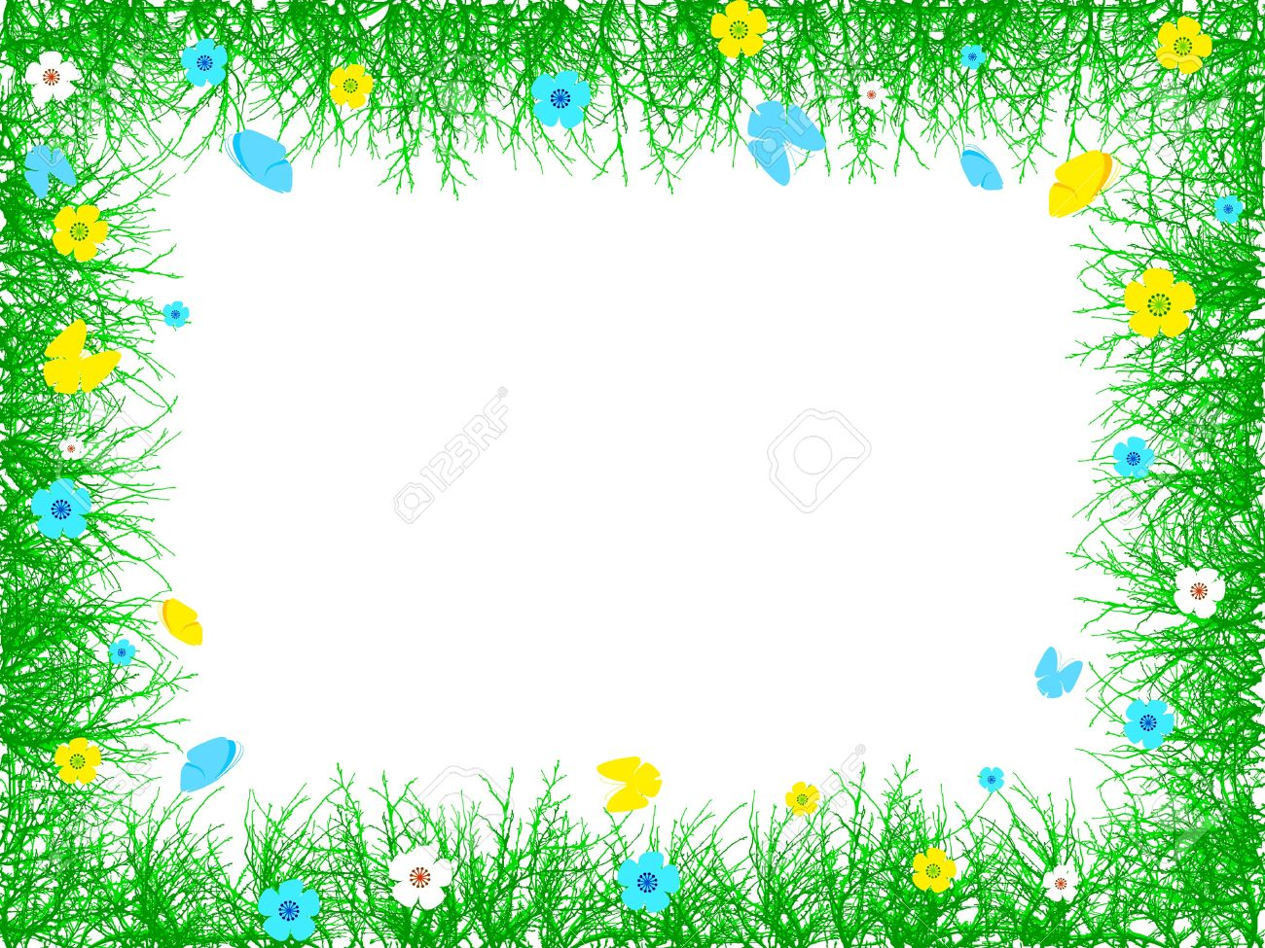
Week of: 3/9-3/13 Theme: Jump into Spring Bible Verse: The birds make their nest” Psalm 104:7
Letter: Zz Number: 22 Color: Green Shape: Hexagon/Shamrock

Art | Writing | Games/Manipulatives | Books
Painting clouds | Making a bird book | Counting and sorting seeds | Reading gardening catalogs and magazines
Making a butterfly suncatcher | Spring writing sentence | Building with bristle builders | Read Chica Chica Boom Boom
Rainbow pom pom painting | Rainbow words | Playing a bean bag game | Reading in “the rain”
Painting with feathers | Writing and recognizing colors | Recognizing Spring words | My favorite Springtime things
Leaf rubbings | Writing with rainbows | Working puzzles | Making a bird box

Week of: 3/23-3/27 Theme: Machines and More Bible Verse: “Work with your hands” I Thess. 4:11
Letter: Qq Number: 23 Color: Green Shape: Shamrock
Art | Writing | Games/Manipulatives | Books
Painting with wheels and axels | Writing with tools | Sorting tools | Reading with flashlights
Creating machines | Sorting letters | Playing with tinker toys | Listening to machines
 | Stamping words | Sorting machines | Playing out a story
Painting with roller machines | Making machine books | Matching nuts and bolts | Reading tools books and magazines
Creating Lazy Susan art | Tracing tools | Hammering nails | Feature an author

