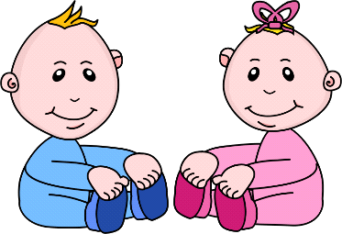Infant Room Lesson Plan
Date: Monday May 15th – Friday May 19^{th,} 2020
Teachers: Ms. Cici, Ms. Jessie, Ms. Carmen, Ms. Christine, and Ms. Emily
Bible verse: "Help one another" (Gal. 5:13)
Making friends
Books  Looking at a photo album: Ask parents to bring in baby photos, pet photos, and family photos, Place the photos in a photo album and show the babies while you rock them. | Motor Development  Lifting Flaps: Find pictures of children in magazines and cut them out. Glue them onto construction paper, fold the paper over. Show the babies how to lift the flaps.
Art  Coloring people on shapes: Cut paper into shapes of moms, dads, and children. Guide the children into coloring the people. Say "God made the people" | Music  Playing quiet music: When the children get tired, put on relaxing music to help them fall asleep.
Nature:  Shaking pom-poms: Make pom-poms by cutting newspaper to strips. Glue the newspaper to potato chip cans. Show babies how to shake their pom poms. | Toys:  Packing a picnic: Gather play fruits and vegetables. Invite the babies to place the food into a picnic basket. Use the bible phrase " we are helpers" talk about helping.

